# Accessing The Microsoft Immigration System

When you receive an email from Global Migration at Microsoft requesting information (see example in Figure 1), follow the instructions in this document to securely access our system!

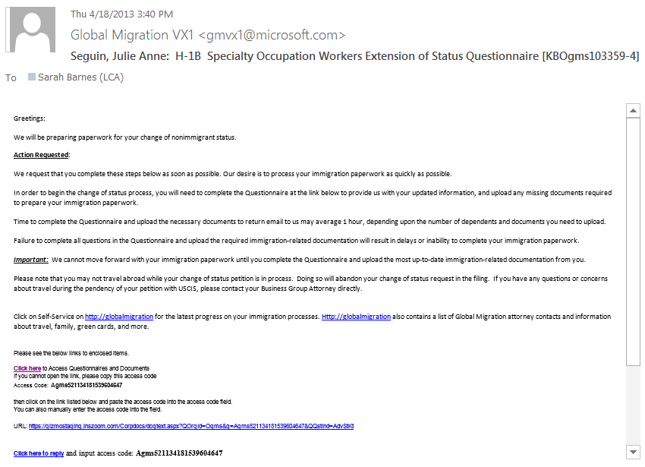

Figure 1

1. Start your access to the Microsoft System by clicking **Click here** in the email (highlighted in Figure 1).

**Note** If the link does not take you to the page described in Step 2, complete the following steps:

1. Copy the access code from the email (highlighted in Figure 1).
2. Click the URL link (highlighted in Figure 1).
3. In the dialog box that appears, paste the access code in the text box and click **OK**.
4. When you click on the link, you should be taken to tha page in Figure 2.

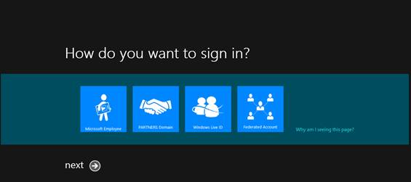

*Figure 2*

1. From this page, select Windows Live ID (highlighted in Figure 2) and click **Next**. This will bring up the screen in Figure 3.

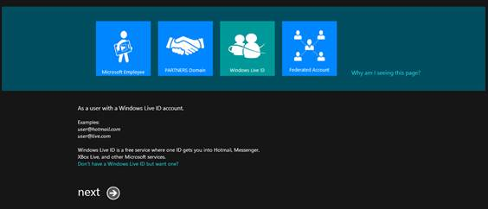

*Figure 3*

1. Click **Next**. This will bring up the screen in Figure 4.

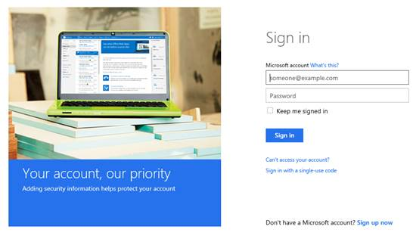

*Figure 4*

1. Use your Microsoft Account to sign in. This will take you to Figure 5, where you are ready to respond to the questionnaire and upload any relevant documents!

**Note** If you do not have a Microsoft Account, click **Sign up Now** to sign up for a free Microsoft email account.

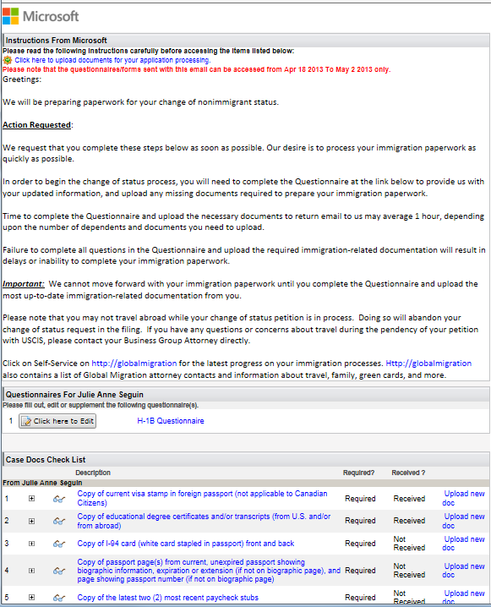

*Figure 5*